IS303 Problem Set 3 Question 1: Fixing multi-threaded code

About this question / Instructions
- This code set will demonstrate one possible failure due to running multiple threads on code which is not thread safe.
- Run the code in ‘push mode’ as described below; determine the number of concurrent threads and identify them.
- Run the code in ‘pull mode’ with one client, so you are able to observe the intended behavior. Then run with a few clients until you are able to observe errors due to the unsafe code.
- Use java.util.concurrent.locks.ReentrantReadWriteLock to fix the code so that it is thread safe. Run it a few times to verify – try to make it fail in your verification. Explain the changes you made and submit the files changed.
Objectives
- You will get experience observing potential errors in a multi-threaded environment.
- You will get practice reading and debugging multi-threaded code.
- You may (not required) use the programs in this lab to observe the different effects of push/pull scenarios by modifying experimental parameters (e.g. message size, message buffer size, frequency of polling interval etc)
Description
You are given 7 Java classes as well as their source files & 3 properties files:
  - EventGenerator.java
  - MessageBuffer.java

  - EventSource.java (contains main)
  - eventsource.properties (used by EventSource)

  - PullClient.java (contains main)
  - pullclient.properties (used by PullClient)
  - PullServer.java

  - PushClient.java
  - PushServer.java (contains main)
  - pushserver.properties (used by PushServer)

The following schematic diagram shows how the classes & properties files above are related when the experiment runs:
eventsource.properties
Read by
Event Source

Pull Client
pullclient.properties
request
message
Push Server
pushserver.properties

Event Generator
Pull Server
Read by
message
Create(thread)
Message Buffer
(stores message)
PULL mode

Push Client
Read by
PUSH mode
message
Create (thread)
Create (thread)

message

message

In the preceding diagram, solid arrows depict data flow. Shaded boxes depict classes with a main method.
Some notes to aid you in running the code:
- eventsource.properties contains an important attribute: mode, which can be set to PUSH or PULL. The code can run in either PUSH or PULL mode only.
  - In PUSH mode, you need to run PushServer, followed by EventSource (which creates a PushClient thread) in a separate DOS command window.
  - In PULL mode, you need to run EventSource (which creates a PullServer thread), followed by PullClient in a separate DOS command window. The PullClient needs a parameter to identify it (ie “java PullClient 0”, “java PullClient 1”, “java PullClient 2” …)
- The term “server” in this context represents a component listening at a particular TCP port for a client to connect. A “client” connects to a server at that port.
  - In PUSH mode, the client is the message producer while the server is the message consumer.
  - In PULL mode, the server is the producer and the client is the consumer (refer to the diagram above).
- EventSource creates new threads:
  - In PUSH mode: an EventGenerator thread & a PushClient thread
  - In PULL mode: an EventGenerator thread & PullServer threads (up to the number of clients specified in the properties file).
  - As its name implies, EventGenerator generates “events” at random intervals & stores a new String message in the shared instance of MessageBuffer whenever a new event occurs. In this lab, a new event is manifested by the creation of a new String message and appending of that new message to the shared MessageBuffer.
- In PUSH mode, the PushClient continually checks the shared MessageBuffer for messages, extracts any messages stored there & pushes them to the PushServer immediately.
- In PULL mode, each PullClient periodically sends a request to a PullServer. When the PullServer gets the request, it checks the MessageBuffer, extracts any messages stored there, & sends them back to that PullClient, then clears them from the MessageBuffer. This should work like JMS-Queues: whenever client reads the message first is the only one to get it.
- The 3 properties files contain attribute/value pairs which are read by EventSource, PushServer & PullClient respectively when they start executing. The experiment parameters can be modified using the values in these properties files before running the respective Java programs.

Instructions – This lab
- You must have Java 5 (JDK 1.5) or higher runtime installed on your laptop (the code uses Java 5 features). You will need to compile the code. Make sure that your environment is correctly set to run the Java classes. When EventSource, PushServer and PullClient start running, they will search for their respective properties files in the same directory, so do ensure that the properties files are in the same directory as the class files.
- Run the application in PUSH mode:
  - Set the mode property to push in eventsource.properties and save the file.
  - Open a DOS window and start PushServer (java PushServer)
  - Open a 2nd DOS window and start EventSource (java EventSource)
- Determine the maximum number of concurrent threads and identify them.
- Run the application in PULL mode with one client, and observe the behavior. Note the number of events generated and received. Then run the application in PULL mode with a few clients (3 is recommended to get the bug to display itself) – you’ll need a separate window for each client. It’s recommended you use a high frequency of event generation and a high frequency of pulls (this has been done in the original properties file already).
  - Set the mode property to pull and numPullClients property to 3 in eventsource.properties and save the file.
  - Open a DOS window and start EventSource (java EventSource)
  - Open a 2nd DOS window and start PullClient (java PullClient 0)
  - Open a 3rd DOS window and start another instance of PullClient (java PullClient 1)
  - Open a 4th DOS window and start a 3rd instance of PullClient (java PullClient 2)
- Look through the source code of all given files.
Fix the code so that it is thread safe – use java.util.concurrent.locks.ReentrantReadWriteLock (synchronized will work, but the ReentrantReadWriteLock will show you another way). Run it a few times to verify. B) Explain the changes you made and submit the files changed.
- You may which to further explore the 3 properties files & the attributes which can be modified within. You are NOT required to answer the questions in the old lab.

Appendix – OLD lab
The old lab is described below. You are NOT required to perform the experiments below (nor answer the 2 questions), but you may find this helpful for understanding the application, or interesting in itself.
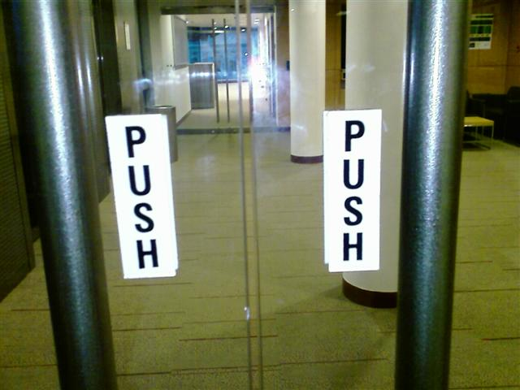
- We are going to perform a simple PUSH experiment. In eventsource.properties, set the following attributes to the values shown below & save the file.
Attribute | Value | Comments
mode | push
period | 60 | This experiment will last for 60 seconds.
eventFrequency | 20 | There will be 20 events happening within 60s. (If period is set to 120, a value of 20 for eventFrequency will result in 40 events happening within the experimental period.)
bufferSize | 200 | The message buffer can only store up to 200 characters
msgSize | 35 | The actual message content will consist of 35 characters. Since each message has a mandatory overhead of 15 characters (for the separators & timestamp), each message for this experiment will be effectively (35+15) characters in length.
ipOfEventListener | 127.0.0.1 | For this experiment, you can run both the EventSource & PushServer (the event listener) on the same laptop, so specify a loopback address.
portOfServer | 4444 | This is the port number used by servers. In this case the PushServer will be listening at this port number. Choose another value if port 4444 is already being used by another program.
dropNewCharWhenBufferFull | true | When the message buffer is full (i.e. it has reached the length specified in bufferSize), attempts to insert new event messages will result in these new messages being dropped. If this attribute is set to false, new messages will be entered into the buffer & old characters already in the buffer will be removed instead.
It is important that the attributes in properties files are set to valid values. Invalid values will cause the program to terminate immediately when you run them.
- In pushserver.properties, set the following attributes to the values shown below & save the file.
Attribute | Value | Comments
period | 60 | This value should be the same as period in eventsource.properties
portOfServer | 4444 | PushServer will be listening at this port for PushClient.
commOverhead | 10 | “Communication overhead” is the additional network load (besides actual data traffic) which is placed on the wire whenever a network call occurs. The unit used here is number of characters. This value can vary based on the network communications protocol used, & is a simulated value in this experiment.

- Open a command window & run PushServer:
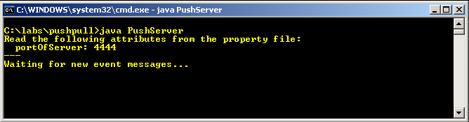
- Open another command window & place both windows side by side so that you can observe the contents of both windows. Run EventSource in the second window:
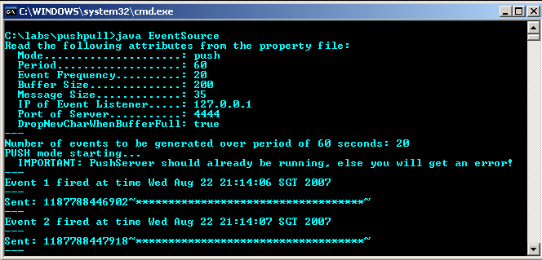
- Observe both windows simultaneously. When EventSource fires an event, the accompanying message is (almost) instantaneously sent over to PushServer & appears in PushServer’s window. Message delay is defined as the time difference between the creation of the message in the EventSource window (as recorded on its timestamp) & the time the message is received in the PushServer window. The message delay is displayed for each message received in the PushServer window.
- When the experiment ends (after 60 seconds), a summary of delay statistics & network traffic (in number of characters sent over) will be printed out.

Part 3 – Guided Pull Experiment
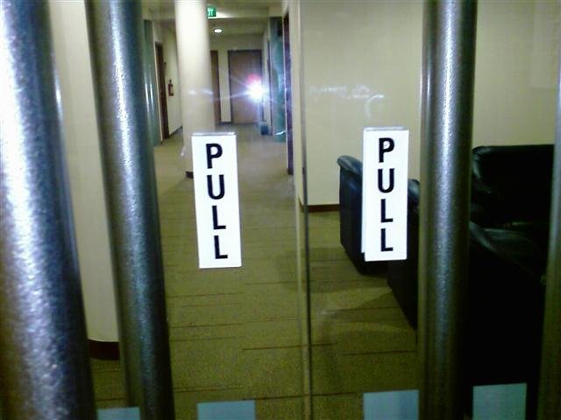
- Now that you understand how to run the experiment in PUSH mode, it’s time to do it in PULL mode. Change the mode attribute in eventsource.properties to pull & save the file:
Attribute | Value | Comments
mode | pull

- In pullclient.properties, set the following attributes to the values shown below & save the file.
Attribute | Value | Comments
period | 60 | This value should be the same, or longer, as period in eventsource.properties
portOfServer | 4444 | PullServer will be listening at this port for PullClient.
ipOfPullServer | 127.0.0.1 | (as explained previously)
pullInterval | 5000 | This is the time taken between pulls initiated from the PullClient in milliseconds. Set the pull interval to 5000 (i.e. 5 secs) for this experiment; this will cause the PullClient to send a request to PullServer every 5 seconds for messages.
commOverhead | 10 | (as explained previously)

- We are ready for the PULL experiment to start. Run EventSource in the first command window:
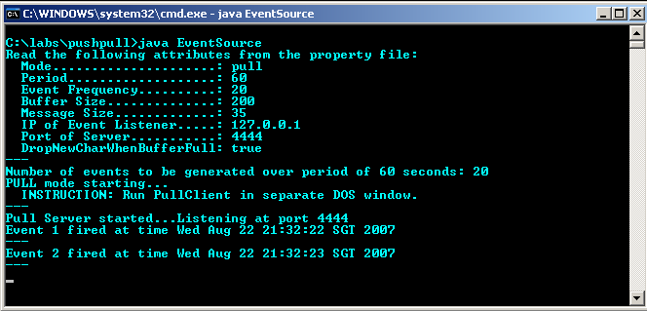
Realize that events start getting fired when EventSource runs. Also notice that after a while, if the messages are not pulled from the PullClient (which isn’t running yet), the message buffer starts to get filled up & data gets dropped:
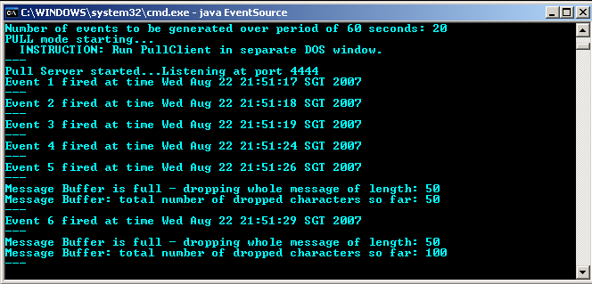
You are given a running total of the number of characters dropped from the message buffer in the experiment. Remember that for this experiment, the actual length of each message is 50 characters (msgSize = 35, plus 15 characters for the timestamp & separator characters), & the message buffer’s size is only 200 characters. This implies that as long as no one is extracting messages from the buffer, it cannot hold more than 4 messages at any one time.
- Let the experiment end (let EventSource finish running – you will have to hit Ctrl-C when the message “Exiting EventGenerator thread” appears). This time we are going to repeat the experiment with PullClient running & consuming messages from the message buffer.
- Run EventSource in the first window, followed by PullClient in the second window. PullClient will send requests periodically to the PullServer (once every 5 seconds). When PullServer gets a request, it will send all the messages stored in the message buffer to PullClient & clear the buffer.
Notice that “clumps” of messages may be retrieved during each “pull” from the PullClient as shown in the next screenshot (may vary because events are fired randomly).
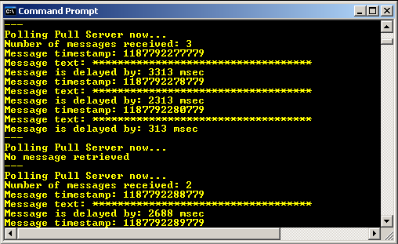
- As before, when the experiment ends, statistics are shown about the delays experienced by messages received at PullClient, as well as the network traffic utilized.
QUESTION 1:
Compare & comment on the delay statistics for both experiments. Also note whether any messages got lost in the PULL experiment for the current settings.

Part 4 – New BOSS Biding Notification System
The BOSS bidding system is causing unnecessary stress to SMU students. Students who have placed bids for popular courses suffer nervous breakdowns waiting for the outcomes. The university has finally decided to revamp the whole system to cut down the number of psychiatric-related diseases.
Strangely, another rule has kicked in as well: all students must bid for only 5 (no more, no less) courses per semester.
In the new BOSS, the results for each course will be released independently over a window period of 10 minutes (so that the results of each course will be an independent event happening during a random time within the 10-minute window). These 10 minutes can be nerve-wracking & the university wants all students to be informed within 30 seconds from the time when the result of a bid comes out. The university is studying 2 ways for students to be notified of the bidding results:
- The traditional way: i.e. by visiting a particular Web page which shows all available results. It is hence possible for a student to log in during the 10 minute window & see only results for 3 out of her 5 bids. You can assume that students will refresh the Web page once every 30 seconds to get the latest results.
- The SMS way: a brand new SMS system can be purchased & hooked up to BOSS, so that when a bidding result is available, an SMS is sent immediately to the student. This means that each bidder will get 5 SMSes by the end of the 10 minute window.
Here are some useful values you can use for this problem:
- A HTTP-based communication with the BOSS Web site will always be a packet of size 9000 characters or more if data is tagged to it.
- An SMS-based communication will always take the size of 1000 characters or more.
- Each bid outcome notification will be 2000 characters in length (be it sent through SMS or via the Web)

QUESTION 2:
Design an experiment based on this scenario & perform at least 3 simulation runs. Then fill up the following table:
 | Maximum delay | Average delay | Minimum delay | Number of characters sent over the Network
Web-based notification
SMS-based notification

Show clearly the parameter values set in the relevant properties file for your experiment and reasons for choosing these values if they are interesting.
Do a simple analysis of the alternatives & put up a recommendation (in a short paragraph) to the university as to which should be implemented.

Part 5 – Hot Stocks
Armed with some stock market knowledge after taking the FIIM (Financial Instruments, Institutions & Market) course, you have embarked on an internship with an online stock broking company. To your joy/dismay, you have been given the critical task of designing a stock ticker application which users can view through a Web browser.
After a preliminary discussion with your co-workers, it seems that there are 2 viable ways to get information to users who are monitoring a particular stock:
- Show the latest stock value on a plain old HTML-only Web page. The user must continually refresh her browser to get the latest data.
- Embed a Java applet into the Web page. When the user visits the page, the stock-ticker applet gets downloaded to the user’s Web browser cache & runs there. This stock-ticker applet maintains a constant communication pipeline with a server process running at your company’s Web server such that when a change in the stock value happens, the latest value is sent down to the applet immediately. The applet then updates its display on the user’s Web page. This way, the user does not have to keep refreshing his browser to get the latest values.

You can assume the following:
- All users will want an update on the stock value every 15 minutes. It usually does not matter to a user if he misses a price change within that period (he wants only the latest price every 15 minutes).
- The stock being monitored is moderately active with a price change every 2 minutes on average.
- Requesting a price update involves a HTTP request (sent off when you hit the F5 function key when the Web browser is active) of size equivalent to 9000 characters.
- The stock price data makes up a message of only 2000 characters be it sent through the applet pipe or tagged to a HTTP response. Assume that all setup traffic (registration, exchange of passwords, etc.) can be ignored.
QUESTION 3:
For each scenario, design & perform the necessary simulation runs, consider the relative efficiency of push- vs. pull-style interaction, then present your recommendations with relevant supporting data/justifications.
Remember to show clearly the parameter values set in the relevant properties file for your experiment and reasons for choosing these values if they are interesting.

That’s all for now!

